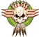 | Cake  June 2015 | 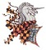 | Bubba  March 2018 |  | Exebowl  October 2014 | 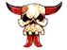 | SAW  April 2017
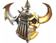 | ARBBL  November 2016 | 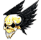 | Crumb  April 2016 |  | ARBBL  March 2015 | 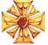 | Thrud  August 2016
 | Bubba  March 2017 | 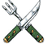 | Cake  June 2017 | 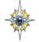 | NAFC  April 2017 | 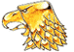 | Bubba  February 2016
 | Exebowl  October 2017 | 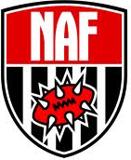  ENDERMAN  Played all NAF races – April 2018 |  |  |  | 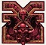 | Waterbowl  February 2017
 | Crumb  April 2015 | 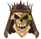 | SAW  April 2018 | 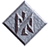 | Thrud  August 2017 | 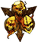 | ARBBL  November 2016
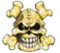 | Exebowl  October 2016 | 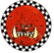 | Bubba  February 2015 | 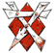 | Birthday  May 2015 | 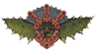 | Vault  October 2017
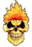 | Thrudball  August 2014 | 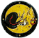 | Foul  June 2017 | 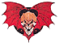 | Block of Holding  May 2017 | 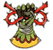 | Cake  June 2016

